|  |
| --- |
| MGMT 6059– Section 01 |
| Assignment – 03  Project Management Software Applications |
|  |

|  |
| --- |
|  |
| Name: Gihan Shamike Liyanage  Student Id: 1142109  Date: November 28, 2023 |
|  |

## Question 3

* On what date does the planned work begin to diverge from the actual work?

Answer: January 20th, 2009

## Question 4

* What percentage of the project has been completed?

Answer: 64%

## Question 5

* Which resource has the highest amount of work remaining in this project?

Answer: Gihan09

* How many hours of work are remaining (to be completed) in this project?

Answer: 452 hours

## Question 6

* How many hours of work does Denise have remaining in this project?

Answer: 50 hours

* Approximately what percentage of work has the dance instructor completed so far in this project?

Answer: 50%

## Question 7

* Which task(s) are currently late?

Answer: Actors and dancers rehearse

## Question 8

## Question 9

## Question 10

Briefly explain how you can determine which tasks are critical when your screen is in Network Diagram view.

Answer: Critical tasks are indicating by red color boxes.

## Question 12

Write down the WBS codes corresponding to the overallocated tasks. Also, describe the symbol in the Entry table which indicates that a task is overallocated.

Answer: 1.1.1, 1.1.2, 1.1.4, 1.1.5, 1.1.6, 1.1.7, 1.1.8, 1.1.9, 1.1.10, 1.1.11

Red color user icon in the indicators column indicates that a task is overallocated.

## Question 13

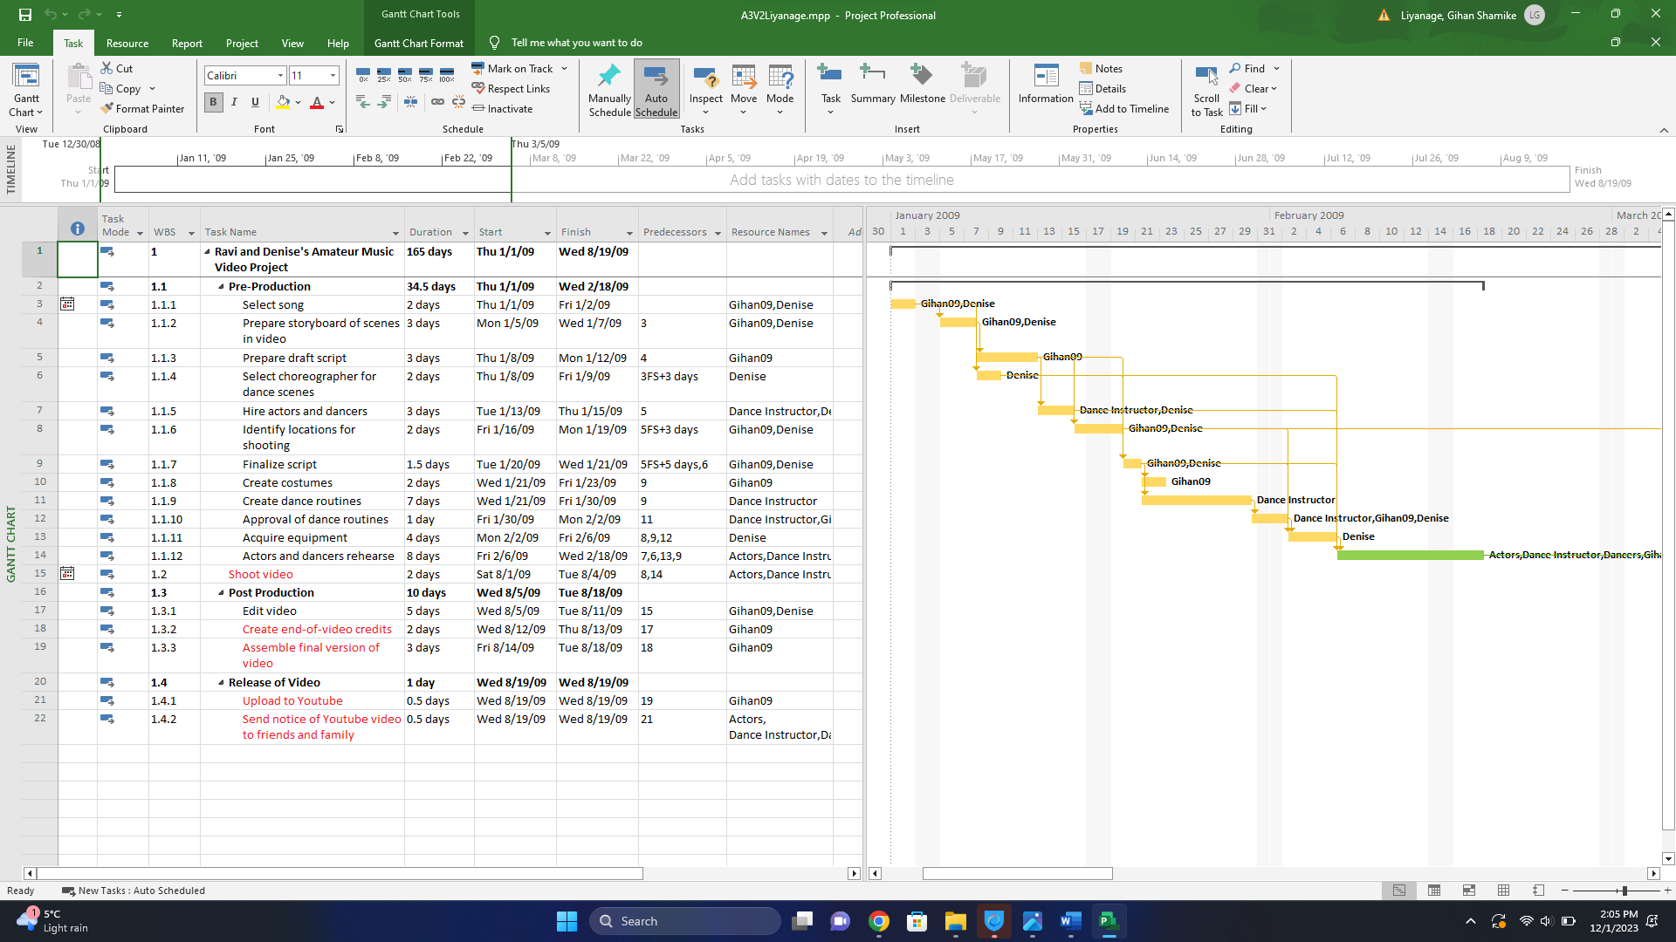

In task 1.1.4 I added 3 days lag to predecessor 1.1.1. – To stop Danise overlapping with task 1.1.2

In task 1.1.6 I added 3 days lag to predecessor 1.1.3. – To stop Danise overlapping with task 1.1.5

In task 1.1.7 I added 5 days lag to predecessor 1.1.3. – To stop Danise and Gihan09’s overlapping with task 1.1.5 and 1.1.6

I added predecessors accordingly to task 1.1.9 and 1.1.10 which were orphan tasks.

## Question 14

Crashing

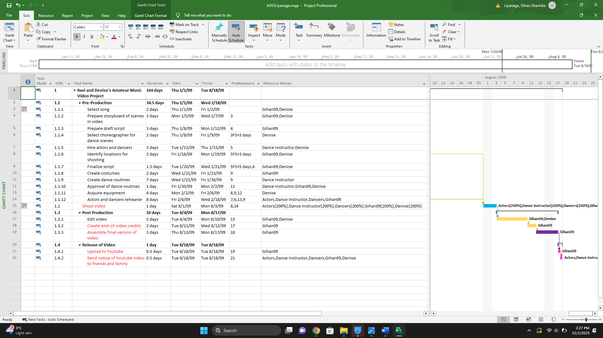

* Reduced the duration of task 1.2 by 1 day by adding more resources.

Fast tracking

* Changed the predecessor of task 1.3.2 from task id 17 to 15

Negative lag

* Add -1 day lag to task 1.3.3.